Campania Region opens an R&I aeronautics call on its RIS3 priorities aligned with Clean Sky 2

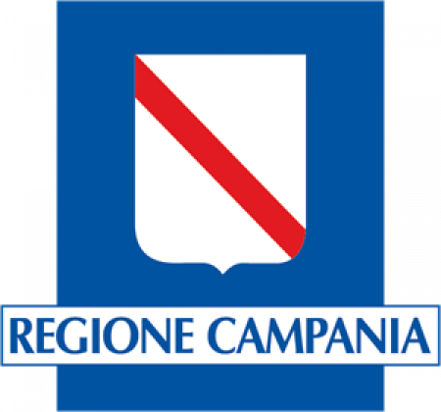

09 December 2019

A regional call was launched by the Campania Region of Italy on 15 November 2019 which allocates €20 million of available funding for regional aeronautics priorities aligned to the Clean Sky 2 programme.

The aim is to fund enabling systems and technologies in aeronautics to accelerate innovation processes in the local industry.

This is the second call launched by the Region as part of the Memorandum of Understanding signed with Clean Sky, which aims to promote synergies between European research and innovation funds and the ESI funds managed by Campania Region.

The deadline for applications is 9 January 2020. Clean Sky participants based in the Region are encouraged to apply to propose complementary projects relevant for the RIS3 priorities mentioned in the call.

All information about the call is available [here](http://ris3.regione.campania.it/index.php/news/notizie/600-progetti-di-r-s-per-sistemi-e-tecnologie-abilitanti-per-l-industria-dell-aerospazio).